# **ChoiceBased Game in C++**

## Clients

Mapua University, Self Made Project for Computer Subject

## Objective / Goals / Purpose

The study aims to create a text-based game where the choices the player makes is relevant to the completion of the game. The game is written in C++ as a requirement for a finals project for the course

## Technologies Used

C++

## Description

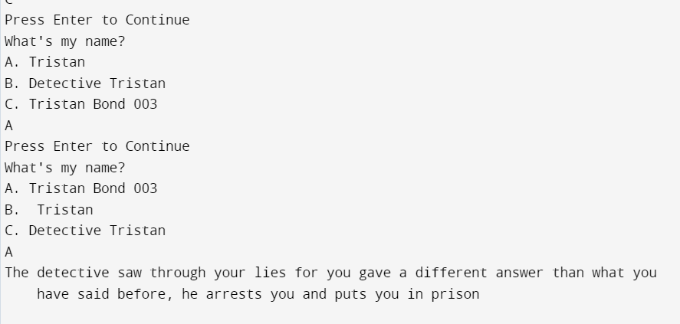

The program keeps track of the user's previous responses. If the user gives a different answer to a previously asked question, they will lose the game. The objective is for the player to recall all their previous answers, as the system will present questions from a question bank twice during the game.